## **Objectives**

* Explain various ways of conditional rendering
* Explain how to render multiple components
* Define list component
* Explain about keys in React applications
* Explain how to extract components with keys
* Explain React Map, map() function

In this hands-on lab, you will learn how to:

* Implement conditional rendering in React applications

## **Prerequisites**

The following is required to complete this hands-on lab:

* Node.js
* NPM
* Visual Studio Code

## **Notes**

Estimated time to complete this lab: **60 minutes.**

Create a React App named “bloggerapp” in with 3 components.

1. Book Details
2. Blog Details
3. Course Details

Implement this with as many ways possible of Conditional Rendering.

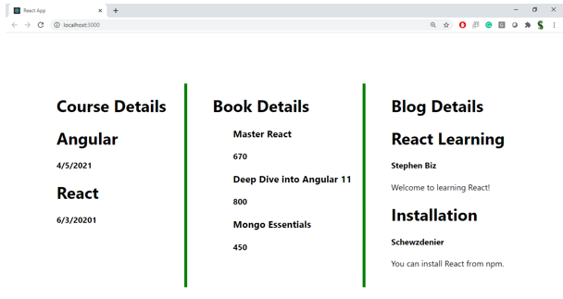

**Hint:**

